**Session 5 - Assignment 4**

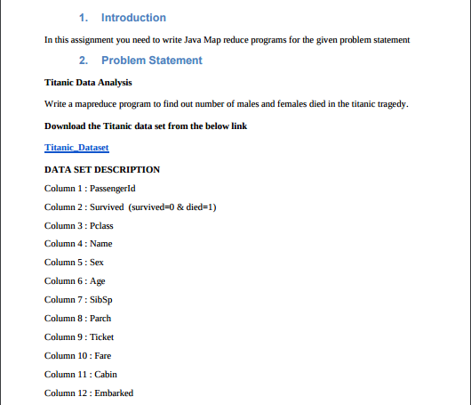

Now we need to find out number of males and females died in the titanic tragedy.

For that we have a data base as input with 12 columns as shown in problem statement.

**Code :**

**Driver :**

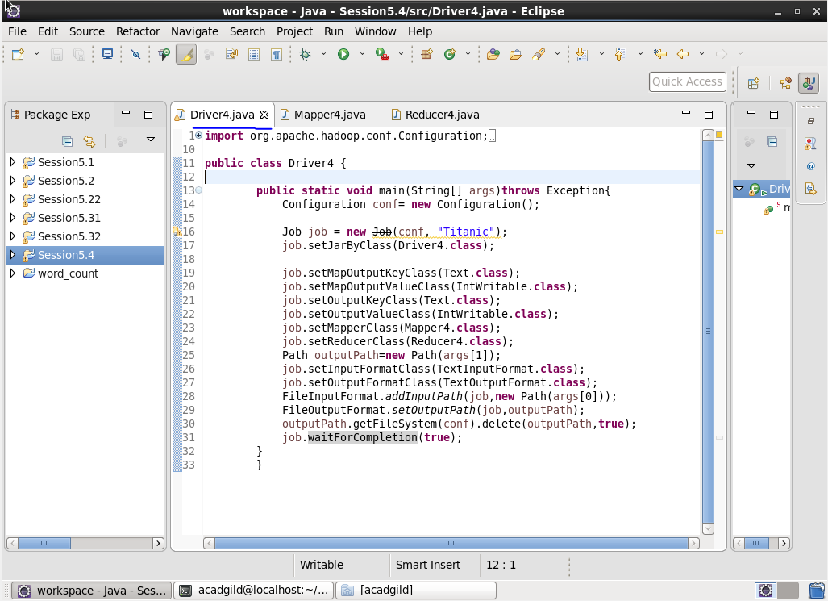

**Mapper :**

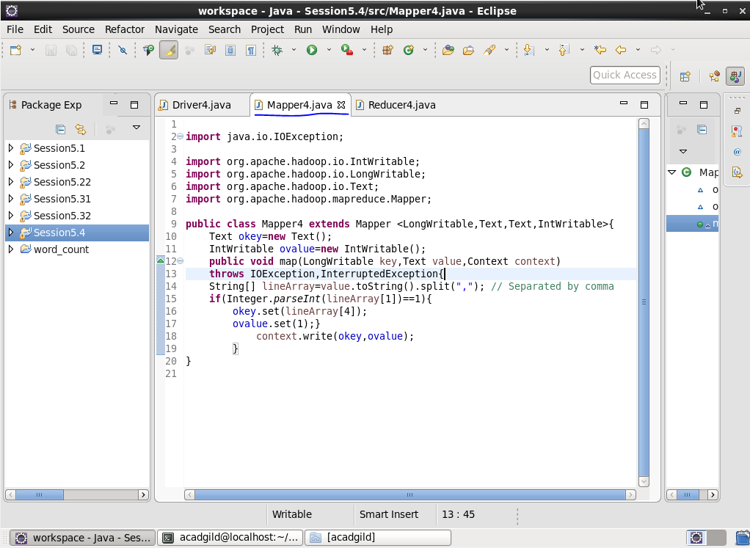

**Reducer :**

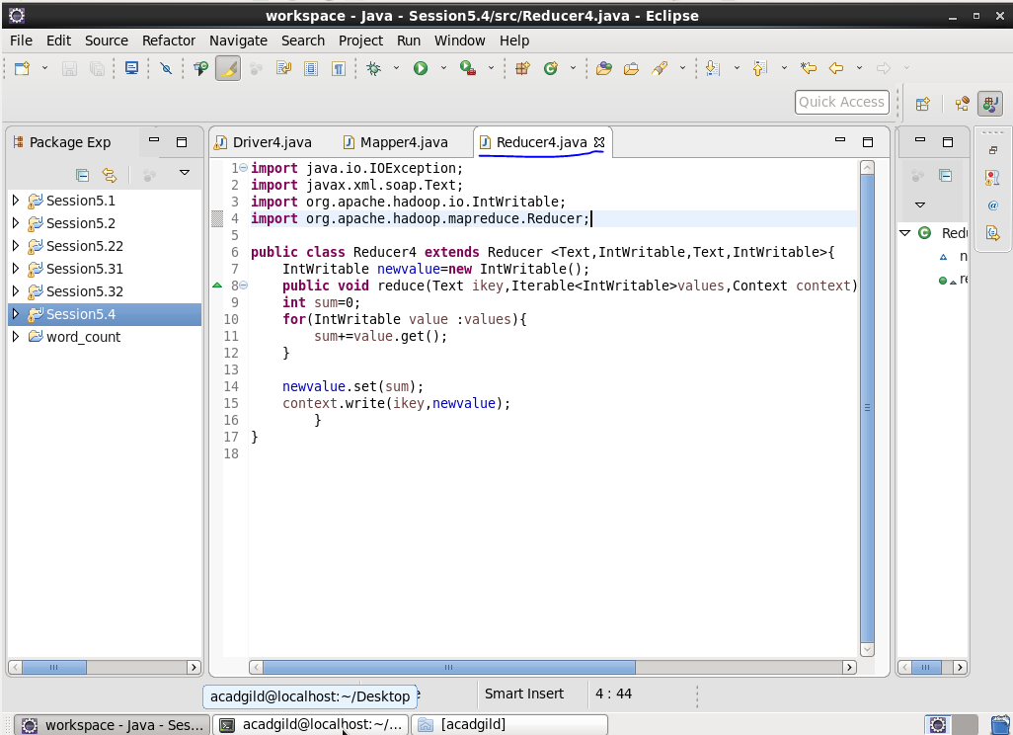

**Input :**

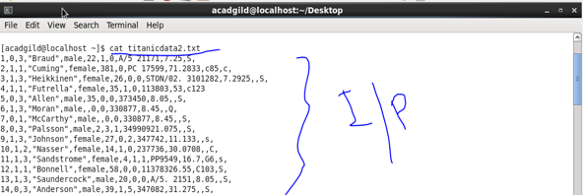

**Output :**

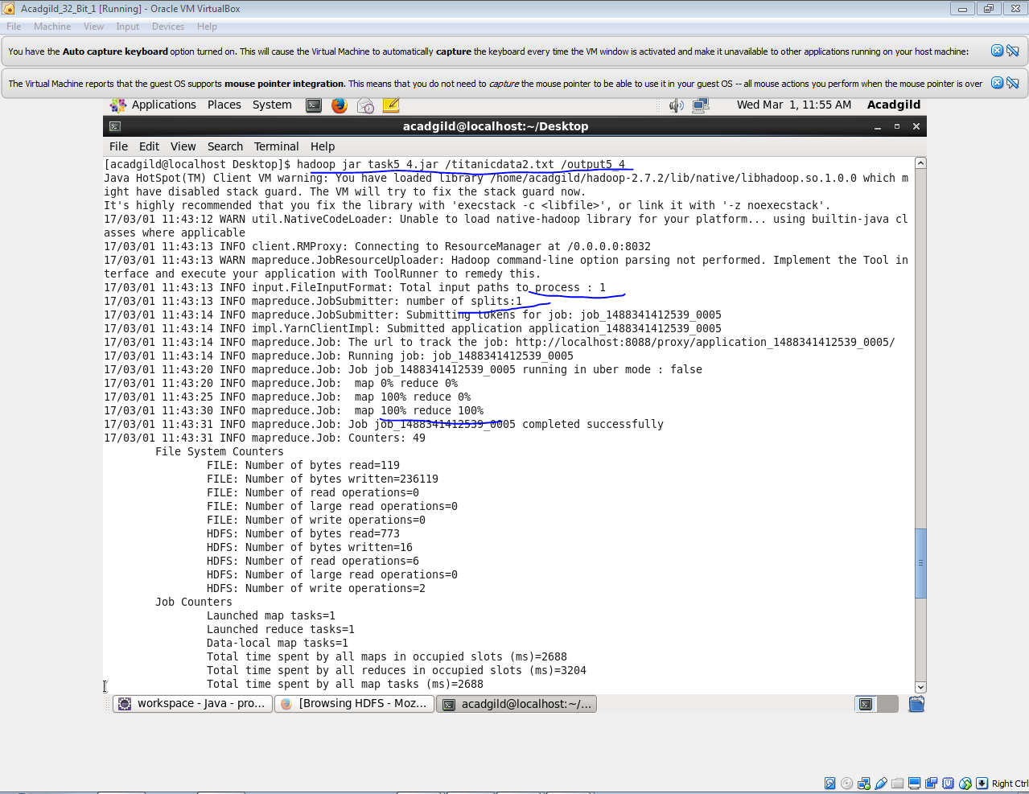

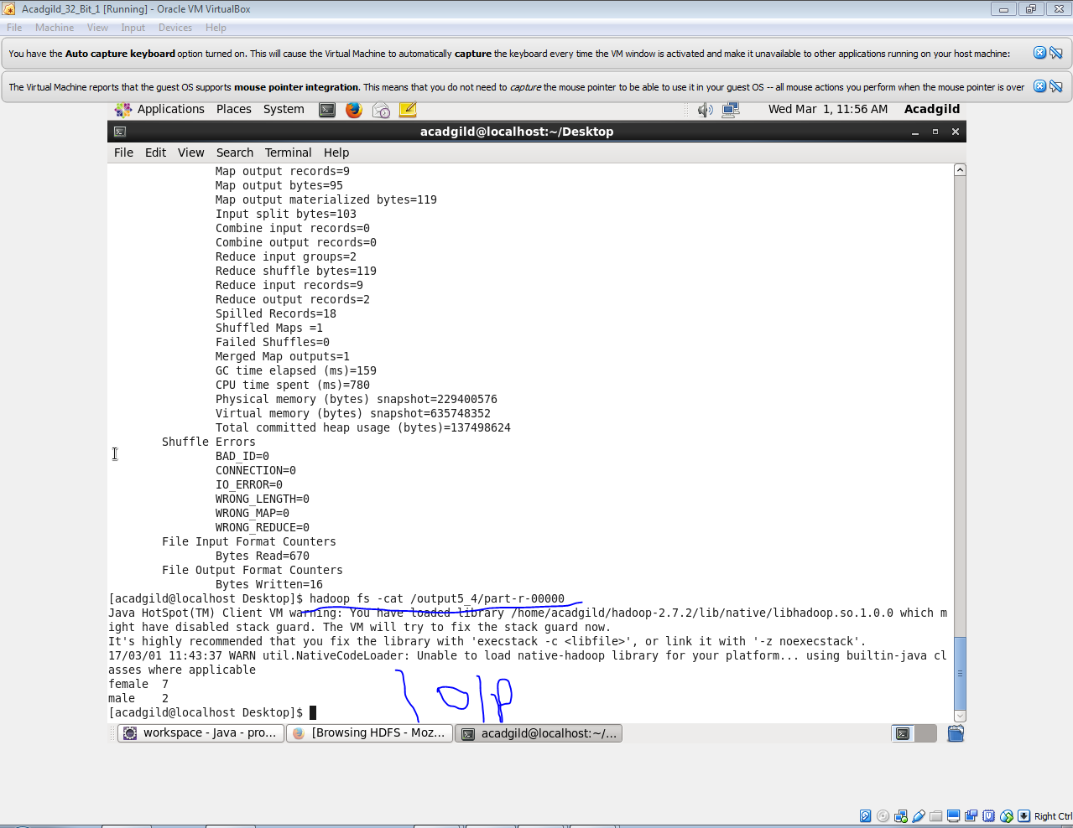

So ,for given data base as input,we got 7 females and 2 males

Were died.